Wavelength Summary Table

Spectral regime | Wavelength | Frequency | Temperature | Types of objects
Gamma Ray
X-ray
Ultraviolet (UV)
Visible
Near-Infrared (NIR)
Mid-infrared (MIR)
Far-infrared (FIR)
Sub-mm and millimetre
Microwave
Radio

For the objects below, write down the numbers of the corresponding images at other wavelengths.

Crab
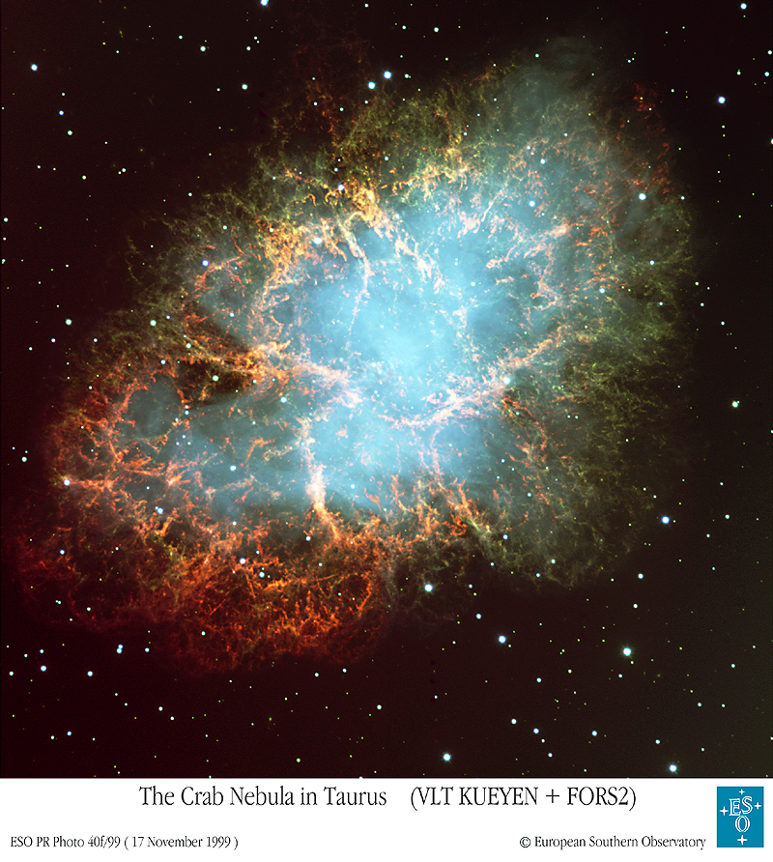
X-ray Ultraviolet

Far-Infrared Radio

Centaurus A
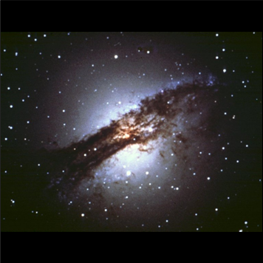
X-ray Mid-Infrared

Far-Infrared Radio

Antennae
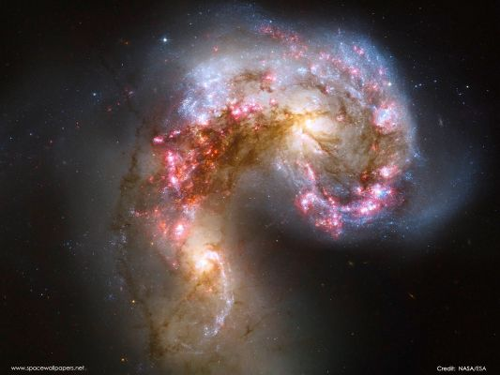
X-ray Mid-Infrared

Far-Infrared Radio

Cassiopeia A
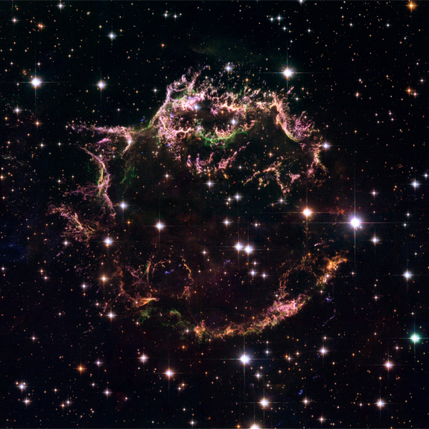
X-ray Mid-Infrared

Far-Infrared Radio

Large Magellanic Cloud
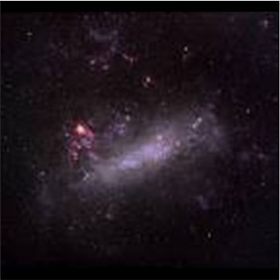
X-ray Ultraviolet

Far-Infrared Radio

Triangulum
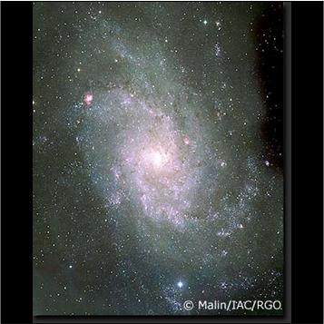
X-ray Ultraviolet

Mid-Infrared Radio

Orion
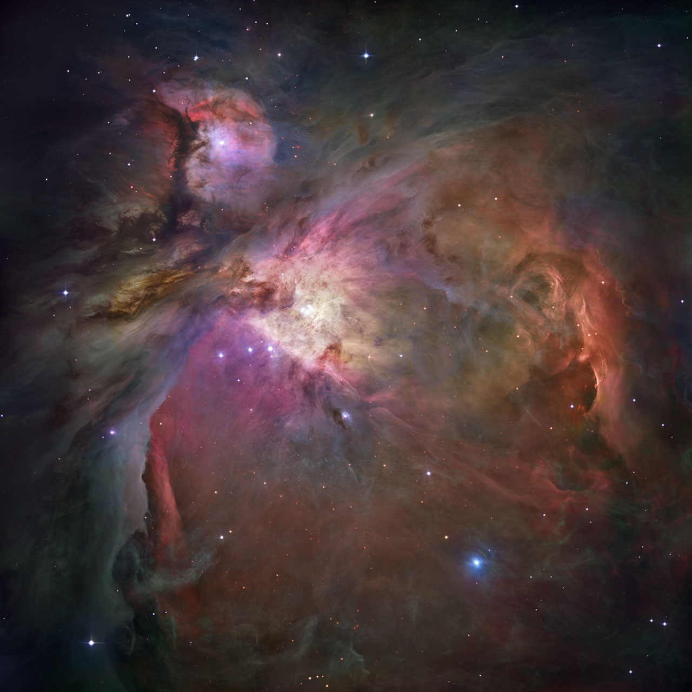
X-ray Near-Infrared

Mid-Infrared Far-IR

M81
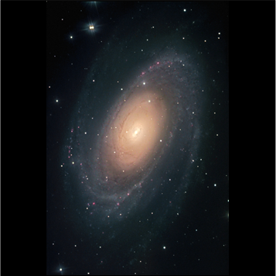
X-ray Ultraviolet

Far-Infrared Radio

M87
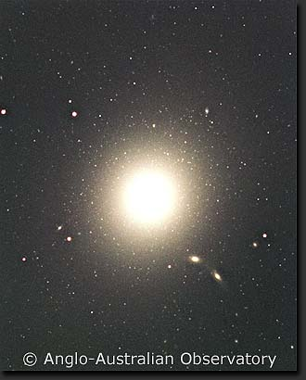
X-ray Mid-Infrared

Far-Infrared Radio

Sombrero

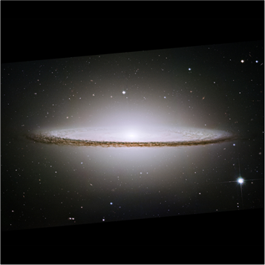X-ray Near-Infrared

Mid-Infrared Radio

M82
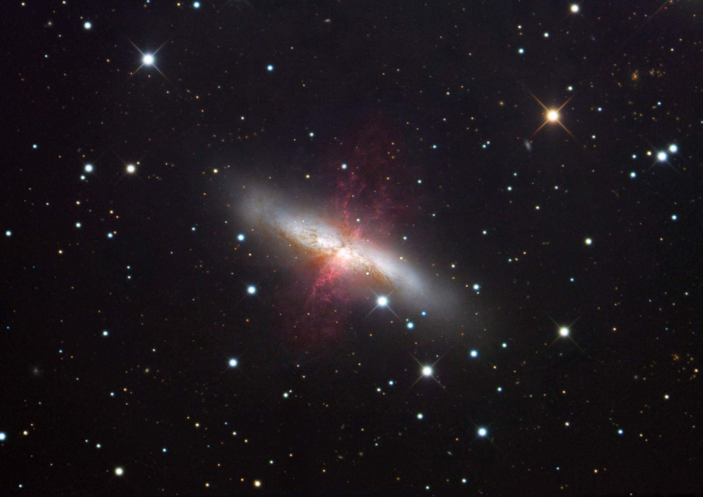
X-ray Mid-Infrared

Far-Infrared Radio

Andromeda
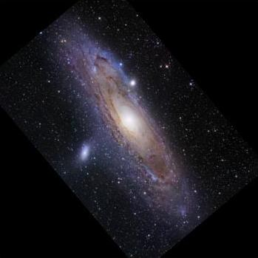
X-ray Ultraviolet

Far-Infrared Radio
Links to Objects

Below are links to the various objects. The codes in brackets are the name you may find it under.

Links are given for finding the object in Chromoscope, as well as a few other links to more details.

Using Chromosope:

- Click the link to open Chromoscope with the object centred.
- Use the “+” and “-” keys (or buttons on the screen) to zoom in and out, and drag the sky around to explore the region.
- Turn on and off constellation labels buy pressing “L”
- Use the slider in the top right to fade between wavelengths shown.
- You can re-order the wavelengths by dragging their names in order to easily compare different wavelengths.
- For more help, press the “h” key.

Crab (M1)

Chromoscope: http://www.chromoscope.net/?l=-175.4429&b=-5.7847&w=2.00&o=g,x,v,a,f,m,r&z=6
Wikipedia: http://en.wikipedia.org/wiki/Crab_Nebula
Cool Cosmos: http://coolcosmos.ipac.caltech.edu/cosmic_classroom/multiwavelength_astronomy/multiwavelength_museum/m1.html
Chandra: http://chandra.harvard.edu/photo/1999/0052/
Spitzer: http://www.spitzer.caltech.edu/Media/mediaimages/sig/sig05-004.shtml
Herschel: http://herschel.cf.ac.uk/results/crab-nebula

Centaurus A (NGC 5128)

Chromoscope: http://www.chromoscope.net/?l=-50.4844&b=19.4172&w=2.00&o=g,x,v,a,f,m,r&z=6
Wikipedia: http://en.wikipedia.org/wiki/Centaurus_A
Cool Cosmos: http://coolcosmos.ipac.caltech.edu/cosmic_classroom/multiwavelength_astronomy/multiwavelength_museum/cenA.html
Chandra: http://chandra.harvard.edu/photo/2008/cena/
Herschel: http://herschel.cf.ac.uk/results/centaurus

Antennae (NGC 4038)

Chromoscope: http://www.chromoscope.net/?l=-73.0444&b=42.4614&w=2.00&o=g,x,v,a,f,m,r&z=6
Wikipedia: http://en.wikipedia.org/wiki/Antennae_Galaxies
Cool Cosmos: http://coolcosmos.ipac.caltech.edu/cosmic_classroom/multiwavelength_astronomy/multiwavelength_museum/ant.html
Chandra: http://chandra.harvard.edu/photo/2000/0120/
Spitzer: http://spitzer.caltech.edu/images/1266-ssc2004-14a%20-Fire-Within-the-Antennae-Galaxies

Cassiopeia A (Cas A)

Chromoscope: http://www.chromoscope.net/?l=111.7353&b=-2.1299&w=2.00&o=g,x,v,a,f,m,r&z=6
Wikipedia: http://en.wikipedia.org/wiki/Cassiopeia_A
Cool Cosmos: http://coolcosmos.ipac.caltech.edu/cosmic_classroom/multiwavelength_astronomy/multiwavelength_museum/casA.html
Chandra: http://chandra.harvard.edu/photo/2006/casa/
Spitzer: http://www.spitzer.caltech.edu/Media/releases/ssc2005-14/release.shtml

Large Magellanic Cloud (LMC)

Chromoscope: http://www.chromoscope.net/?l=-79.5344&b=-32.8887&w=2.00&o=g,x,v,a,f,m,r&z=6
Wikipedia: http://en.wikipedia.org/wiki/Large_Magellanic_Cloud
Cool Cosmos: http://coolcosmos.ipac.caltech.edu/cosmic_classroom/multiwavelength_astronomy/multiwavelength_museum/lmc.html
Herschel: http://herschel.cf.ac.uk/results/centaurus

Triangulum (M33)

Chromoscope: http://www.chromoscope.net/?l=133.6106&b=-31.3308&w=2.00&o=g,x,v,a,f,m,r&z=6
Wikipedia: http://en.wikipedia.org/wiki/Triangulum_Galaxy
Cool Cosmos: http://coolcosmos.ipac.caltech.edu/cosmic_classroom/multiwavelength_astronomy/multiwavelength_museum/m33.html
Spitzer: http://spitzer.caltech.edu/images/2625-sig09-003-Multispectral-Triangulum-Galaxy-3-Channel

Orion (M42)

Chromoscope: http://www.chromoscope.net/?l=-150.9866&b=-19.3813&w=2.00&o=g,x,v,a,f,m,r&z=6
Wikipedia: http://en.wikipedia.org/wiki/Orion_Nebula
Chandra: http://chandra.harvard.edu/photo/2007/orion/
Spitzer:
http://www.spitzer.caltech.edu/Media/releases/ssc2006-21/ssc2006-21a.shtml
Vista: http://www.eso.org/public/news/eso1006/

M81

Chromoscope: http://www.chromoscope.net/?l=142.0920&b=40.8999&w=2.00&o=g,x,v,a,f,m,r&z=6
Wikipedia: http://en.wikipedia.org/wiki/Messier_81
Cool Cosmos: http://coolcosmos.ipac.caltech.edu/cosmic_classroom/multiwavelength_astronomy/multiwavelength_museum/m81.html
Chandra: http://chandra.harvard.edu/photo/2008/m81/
Spitzer: http://spitzer.caltech.edu/images/2126-sig07-009-Multiwavelength-M81

M87

Chromoscope: http://www.chromoscope.net/?l=-76.2224&b=71.4990&w=2.00&o=g,x,v,a,f,m,r&z=6
Wikipedia: http://en.wikipedia.org/wiki/Messier_87
Cool Cosmos: http://coolcosmos.ipac.caltech.edu/cosmic_classroom/multiwavelength_astronomy/multiwavelength_museum/m87.html
Chandra: http://chandra.harvard.edu/photo/2008/m87/

Sombrero (M104)

Chromoscope: http://www.chromoscope.net/?l=-61.5396&b=51.1494&w=2.00&o=g,x,v,a,f,m,r&z=6
Wikipedia: http://en.wikipedia.org/wiki/Sombrero_Galaxy
Cool Cosmos: http://coolcosmos.ipac.caltech.edu/cosmic_classroom/multiwavelength_astronomy/multiwavelength_museum/m104.html
Chandra: http://chandra.harvard.edu/photo/2007/sombrero/
Spitzer: http://www.spitzer.caltech.edu/Media/releases/ssc2005-11/release.shtml

M82

Chromoscope: http://www.chromoscope.net/?l=141.4094&b=40.5667&w=2.00&o=g,x,v,a,f,m,r&z=6
Wikipedia: http://en.wikipedia.org/wiki/Messier_82
Cool Cosmos: http://coolcosmos.ipac.caltech.edu/cosmic_classroom/multiwavelength_astronomy/multiwavelength_museum/m82.html
Chandra: http://chandra.harvard.edu/photo/2006/m82/

Andromeda (M31)

Chromoscope: http://www.chromoscope.net/?l=121.1741&b=-21.5727&w=2.00&o=g,x,v,a,f,m,r&z=6
Wikipedia: http://en.wikipedia.org/wiki/Andromeda_Galaxy
Cool Cosmos: http://coolcosmos.ipac.caltech.edu/cosmic_classroom/multiwavelength_astronomy/multiwavelength_museum/m31.html
Chandra: http://chandra.harvard.edu/photo/2006/m31/
Spitzer: http://www.spitzer.caltech.edu/Media/releases/ssc2005-20/release.shtml
Herschel: http://herschel.cf.ac.uk/results/andromeda-galaxy

Eagle Nebula (M16)

Chromoscope: http://www.chromoscope.net/?l=17.0865&b=1.0684&w=2.00&o=g,x,v,a,n,f,m,r&z=6
Wikipedia: http://en.wikipedia.org/wiki/Eagle_Nebula
Herschel: http://herschel.cf.ac.uk/results/eagle-nebula
Chandra: http://chandra.harvard.edu/photo/2007/m16/

Dumbbell Nebula (M27)

Chromoscope: http://www.chromoscope.net/?l=60.8359&b=-3.6966&w=2.00&o=g,x,v,a,n,f,m,r&z=6
Wikipedia: http://en.wikipedia.org/wiki/Dumbbell_Nebula
Spitzer: http://www.nasa.gov/mission_pages/spitzer/multimedia/pia14417.html

Pleaides (M45)

Chromoscope: http://www.chromoscope.net/?l=166.5707&b=-23.5212&w=2.00&o=g,x,v,a,n,f,m,r&z=6
Wikipedia: http://en.wikipedia.org/wiki/Pleiades
ROSAT: http://heasarc.gsfc.nasa.gov/docs/rosat/gallery/stars_clus_pleiades.html
Spitzer: http://www.spitzer.caltech.edu/images/1766-ssc2007-07b-Pink-Pleiades

Question Sheet

1) What object are you looking at? Describe what it looks like at first sight.

2) Describe where it is in the sky. Is it in the Northern or Southern hemisphere as seen from Earth? Are there any nearby constellations?

3) How far away is it? Is that inside or outside our Galaxy?

4) Describe what type of object it is. Can you find any other pictures of it?

5) Does it look particularly different in any particular wavelengths? Does that tell you anything about it?

6) What can you learn by comparing the appearance of the object at different wavelengths? What is it made of?

7) What is happening to the object? Is it doing anything?

