Activity Outline

This is a brief introduction to the “Multiwavelength Universe” classroom activity. There is at least 2-2.5 hours of material here, so pick and choose accordingly, or split across wavelengths and cover in multiple sessions. Slides are provided for the teacher to illustrate all the sections.

Introduction
- What is EM radiation? (5-10 minutes)
  - Inc. list of wavelengths in EM spectrum (few minutes)
  - Wavelength and frequency
- Optional extra: Herschel introduction (variable length)
- Black Body Radiation (A-level only – 10-15 mins)
  - Inc. Wein’s displacement law
- Optional extra: Draw Black Body curves on the board
- Optional extra: telescope resolutions (A-level only – 10-15 mins)
  - Introduce θ~λ/D
  - Calculate resolution for e.g. Hubble, Lovell, Spitzer, Herschel

Spectrum activities (optional)
- Emission examples at each wavelength (15-20 mins)
  - Fill in wavelength summary sheet
  - Frequency and temperature suggested for A-level students only
  - Ask for examples in real life
  - Ask and/or give examples in astronomy

Online Wavelength matching activity (recommended)
- Match objects at different wavelengths (20 mins)
  - Suggest groups of 2-3 students
  - Suggested illustrative examples (easier): Crab Nebula, or Cas A
  - X-ray and Radio are quite hard to match
  - Overall score is in the bottom right
  - Paper version also available (requires a lot of colour printing!)
    - Answers at the end of this pack

Additional research (optional)
- In their groups of 2-3, or individually
- Use links provided to find more information about objects (30 mins)
  - Suitable questions suggested in question sheet
  - Possible homework activity...
  - Optional: introduce them to Chromoscope www.chromoscope.net
- Optional extra: report back to class
- Optional extra: design poster about objects (template available in package)

For any questions, or to get more details, please contact:
Chris North
School of Physics and Astronomy
Cardiff University
Email: chris.north@astro.cf.ac.uk
Tel: 02920 870 537

Or visit http://herscheltelescope.org.uk/education
Multiwavelength Objects

For the objects below, write down the numbers of the corresponding images at other wavelengths.

Crab
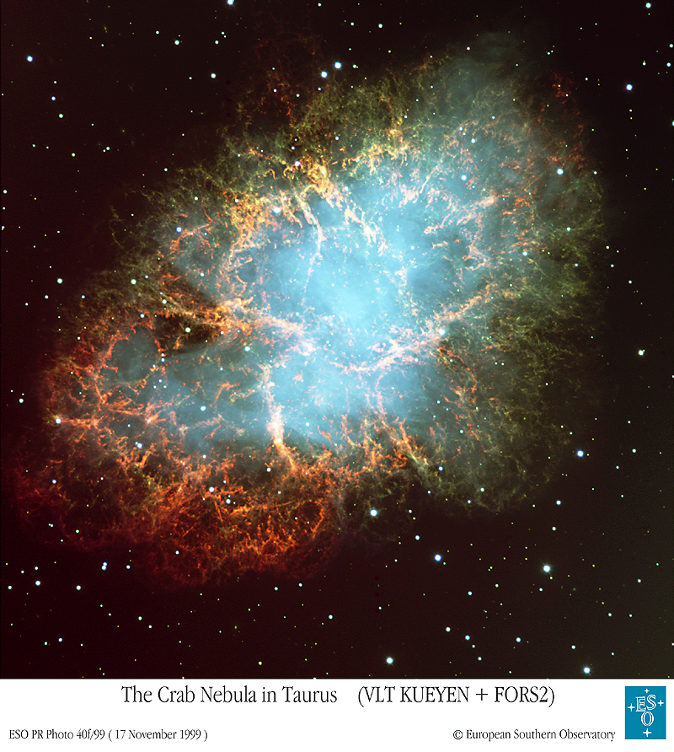
X-ray Ultraviolet

Far-Infrared Radio

Centaurus A
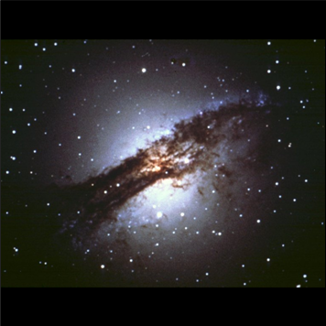
X-ray Mid-Infrared

Far-Infrared Radio

Antennae
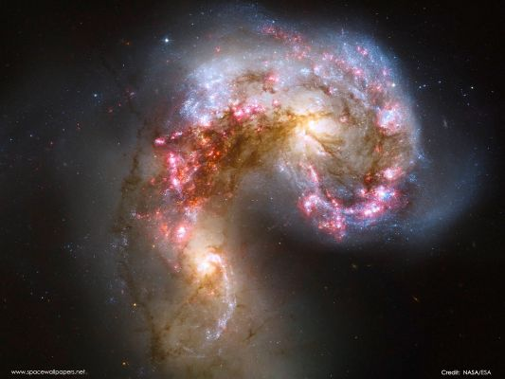
X-ray Mid-Infrared

Far-Infrared Radio

Cassiopeia A
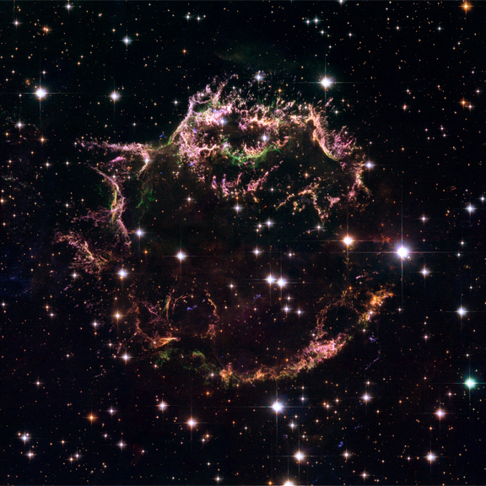
X-ray Mid-Infrared

Far-Infrared Radio

Large Magellanic Cloud
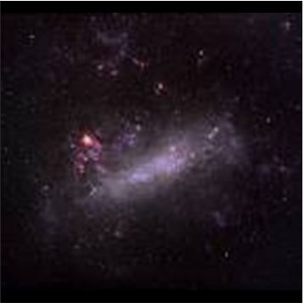
X-ray Ultraviolet

Far-Infrared Radio

Triangulum
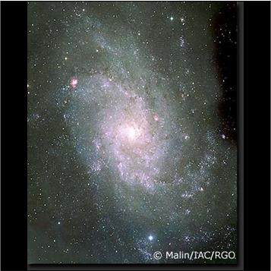
X-ray Ultraviolet

Mid-Infrared Radio

Orion
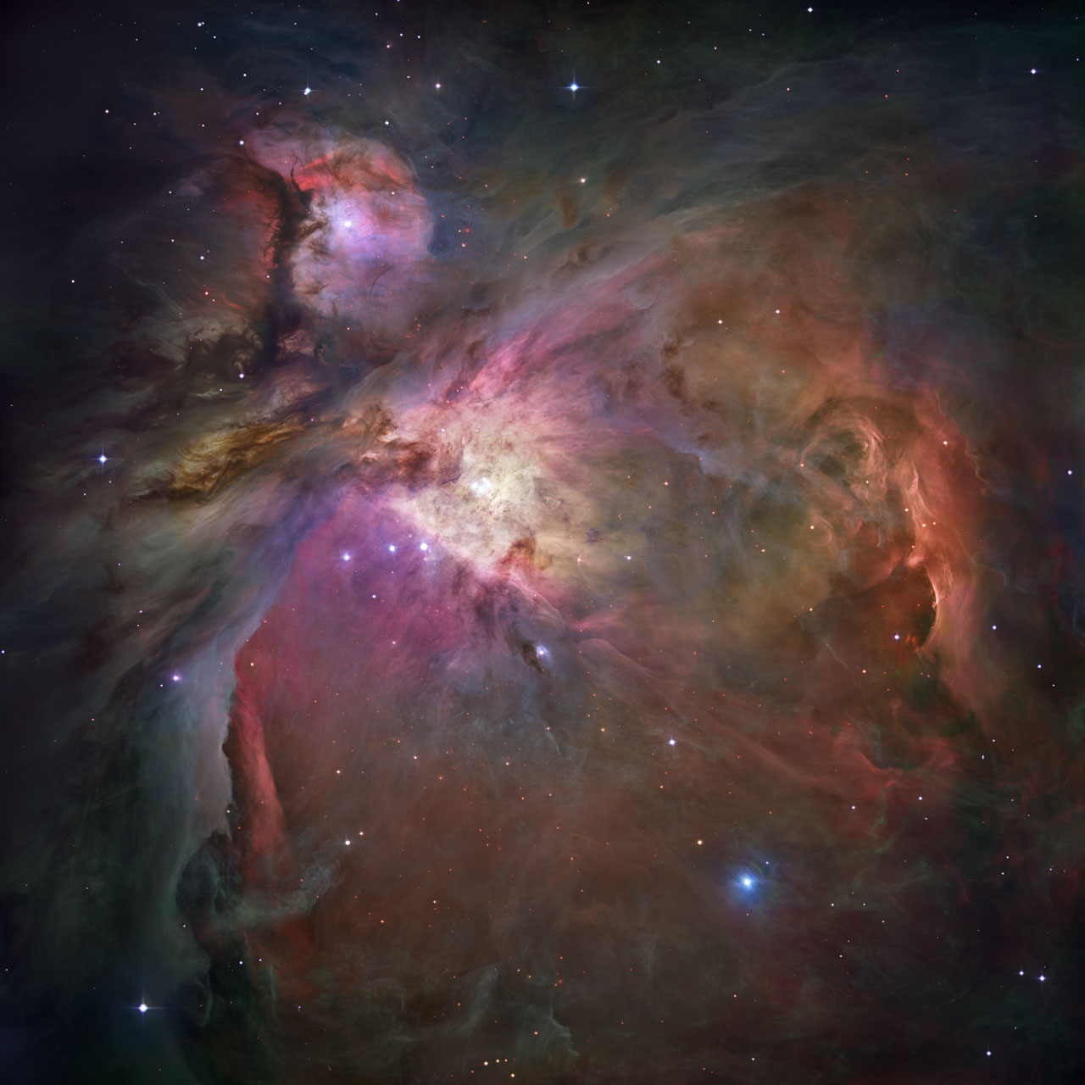
X-ray Near-Infrared

Mid-Infrared Far-IR

M81
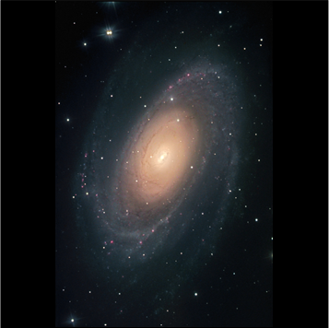
X-ray Ultraviolet

Far-Infrared Radio

M87
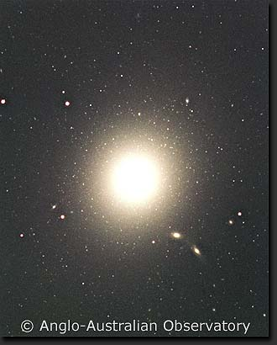
X-ray Mid-Infrared

Far-Infrared Radio

Sombrero

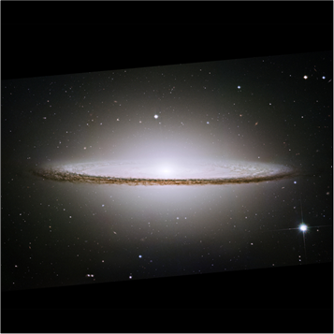X-ray Near-Infrared

Mid-Infrared Radio

M82
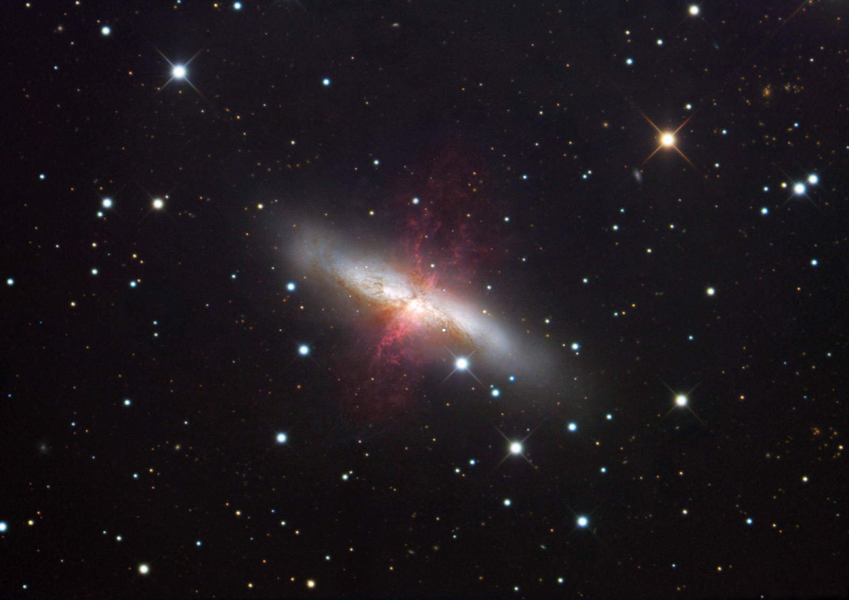
X-ray Mid-Infrared

Far-Infrared Radio

Andromeda
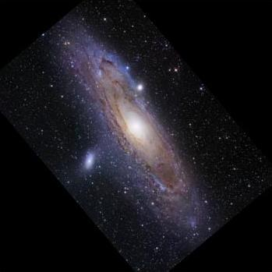
X-ray Ultraviolet

Far-Infrared Radio
Links to Objects

Below are links to the various objects. The codes in brackets are the name you may find it under.

Links are given for finding the object in Chromoscope, as well as a few other links to more details.

Using Chromosope:

- Click the link to open Chromoscope with the object centred.
- Use the “+” and “-” keys (or buttons on the screen) to zoom in and out, and drag the sky around to explore the region.
- Turn on and off constellation labels buy pressing “L”
- Use the slider in the top right to fade between wavelengths shown.
- You can re-order the wavelengths by dragging their names in order to easily compare different wavelengths.
- For more help, press the “h” key.

Crab (M1)

Chromoscope: http://www.chromoscope.net/?l=-175.4429&b=-5.7847&w=2.00&o=g,x,v,a,f,m,r&z=6
Wikipedia: http://en.wikipedia.org/wiki/Crab_Nebula
Cool Cosmos: http://coolcosmos.ipac.caltech.edu/cosmic_classroom/multiwavelength_astronomy/multiwavelength_museum/m1.html
Chandra: http://chandra.harvard.edu/photo/1999/0052/
Spitzer: http://www.spitzer.caltech.edu/Media/mediaimages/sig/sig05-004.shtml
Herschel: http://herschel.cf.ac.uk/results/crab-nebula

Centaurus A (NGC 5128)

Chromoscope: http://www.chromoscope.net/?l=-50.4844&b=19.4172&w=2.00&o=g,x,v,a,f,m,r&z=6
Wikipedia: http://en.wikipedia.org/wiki/Centaurus_A
Cool Cosmos: http://coolcosmos.ipac.caltech.edu/cosmic_classroom/multiwavelength_astronomy/multiwavelength_museum/cenA.html
Chandra: http://chandra.harvard.edu/photo/2008/cena/
Herschel: http://herschel.cf.ac.uk/results/centaurus

Antennae (NGC 4038)

Chromoscope: http://www.chromoscope.net/?l=-73.0444&b=42.4614&w=2.00&o=g,x,v,a,f,m,r&z=6
Wikipedia: http://en.wikipedia.org/wiki/Antennae_Galaxies
Cool Cosmos: http://coolcosmos.ipac.caltech.edu/cosmic_classroom/multiwavelength_astronomy/multiwavelength_museum/ant.html
Chandra: http://chandra.harvard.edu/photo/2000/0120/
Spitzer: http://spitzer.caltech.edu/images/1266-ssc2004-14a%20-Fire-Within-the-Antennae-Galaxies

Cassiopeia A (Cas A)

Chromoscope: http://www.chromoscope.net/?l=111.7353&b=-2.1299&w=2.00&o=g,x,v,a,f,m,r&z=6
Wikipedia: http://en.wikipedia.org/wiki/Cassiopeia_A
Cool Cosmos: http://coolcosmos.ipac.caltech.edu/cosmic_classroom/multiwavelength_astronomy/multiwavelength_museum/casA.html
Chandra: http://chandra.harvard.edu/photo/2006/casa/
Spitzer: http://www.spitzer.caltech.edu/Media/releases/ssc2005-14/release.shtml

Large Magellanic Cloud (LMC)

Chromoscope: http://www.chromoscope.net/?l=-79.5344&b=-32.8887&w=2.00&o=g,x,v,a,f,m,r&z=6
Wikipedia: http://en.wikipedia.org/wiki/Large_Magellanic_Cloud
Cool Cosmos: http://coolcosmos.ipac.caltech.edu/cosmic_classroom/multiwavelength_astronomy/multiwavelength_museum/lmc.html
Herschel: http://herschel.cf.ac.uk/results/centaurus

Triangulum (M33)

Chromoscope: http://www.chromoscope.net/?l=133.6106&b=-31.3308&w=2.00&o=g,x,v,a,f,m,r&z=6
Wikipedia: http://en.wikipedia.org/wiki/Triangulum_Galaxy
Cool Cosmos: http://coolcosmos.ipac.caltech.edu/cosmic_classroom/multiwavelength_astronomy/multiwavelength_museum/m33.html
Spitzer: http://spitzer.caltech.edu/images/2625-sig09-003-Multispectral-Triangulum-Galaxy-3-Channel

Orion (M42)

Chromoscope: http://www.chromoscope.net/?l=-150.9866&b=-19.3813&w=2.00&o=g,x,v,a,f,m,r&z=6
Wikipedia: http://en.wikipedia.org/wiki/Orion_Nebula
Chandra: http://chandra.harvard.edu/photo/2007/orion/
Spitzer:
http://www.spitzer.caltech.edu/Media/releases/ssc2006-21/ssc2006-21a.shtml
Vista: http://www.eso.org/public/news/eso1006/

M81

Chromoscope: http://www.chromoscope.net/?l=142.0920&b=40.8999&w=2.00&o=g,x,v,a,f,m,r&z=6
Wikipedia: http://en.wikipedia.org/wiki/Messier_81
Cool Cosmos: http://coolcosmos.ipac.caltech.edu/cosmic_classroom/multiwavelength_astronomy/multiwavelength_museum/m81.html
Chandra: http://chandra.harvard.edu/photo/2008/m81/
Spitzer: http://spitzer.caltech.edu/images/2126-sig07-009-Multiwavelength-M81

M87

Chromoscope: http://www.chromoscope.net/?l=-76.2224&b=71.4990&w=2.00&o=g,x,v,a,f,m,r&z=6
Wikipedia: http://en.wikipedia.org/wiki/Messier_87
Cool Cosmos: http://coolcosmos.ipac.caltech.edu/cosmic_classroom/multiwavelength_astronomy/multiwavelength_museum/m87.html
Chandra: http://chandra.harvard.edu/photo/2008/m87/

Sombrero (M104)

Chromoscope: http://www.chromoscope.net/?l=-61.5396&b=51.1494&w=2.00&o=g,x,v,a,f,m,r&z=6
Wikipedia: http://en.wikipedia.org/wiki/Sombrero_Galaxy
Cool Cosmos: http://coolcosmos.ipac.caltech.edu/cosmic_classroom/multiwavelength_astronomy/multiwavelength_museum/m104.html
Chandra: http://chandra.harvard.edu/photo/2007/sombrero/
Spitzer: http://www.spitzer.caltech.edu/Media/releases/ssc2005-11/release.shtml

M82

Chromoscope: http://www.chromoscope.net/?l=141.4094&b=40.5667&w=2.00&o=g,x,v,a,f,m,r&z=6
Wikipedia: http://en.wikipedia.org/wiki/Messier_82
Cool Cosmos: http://coolcosmos.ipac.caltech.edu/cosmic_classroom/multiwavelength_astronomy/multiwavelength_museum/m82.html
Chandra: http://chandra.harvard.edu/photo/2006/m82/

Andromeda (M31)

Chromoscope: http://www.chromoscope.net/?l=121.1741&b=-21.5727&w=2.00&o=g,x,v,a,f,m,r&z=6
Wikipedia: http://en.wikipedia.org/wiki/Andromeda_Galaxy
Cool Cosmos: http://coolcosmos.ipac.caltech.edu/cosmic_classroom/multiwavelength_astronomy/multiwavelength_museum/m31.html
Chandra: http://chandra.harvard.edu/photo/2006/m31/
Spitzer: http://www.spitzer.caltech.edu/Media/releases/ssc2005-20/release.shtml
Herschel: http://herschel.cf.ac.uk/results/andromeda-galaxy

Further Research

1) What object are you looking at? Describe what it looks like at first sight.

2) Describe where it is in the sky. Is it in the Northern or Southern hemisphere as seen from Earth? Are there any nearby constellations?

3) How far away is it? Is that inside or outside our Galaxy?

4) Describe what type of object it is. Can you find any other pictures of it?

5) Does it look particularly different in any particular wavelengths? Does that tell you anything about it?

6) What can you learn by comparing the appearance of the object at different wavelengths? What is it made of?

7) What is happening to the object? Is it doing anything?
Wavelength Summary Table

Spectral regime | Wavelength | Frequency | Temperature | Types of objects
Gamma Ray | <20 pm | >1500 PHz | >15,000,000 K
X-ray | 0.02-  10 nm | 30-  1500 PHz | 300,000-  15,000,000 K
Ultraviolet (UV) | 10-  400 nm | 0.75-  30 PHz | 7000-  300,000 K
Visible | 400-  800 nm | 375-750 THz | 3500-  7000 K
Near-Infrared (NIR) | 0.8-  3 m | 100-  375 THz | 1000-  3500 K
Mid-infrared (MIR) | 3-  30 m | 10-  100 THz | 100-  1000 K
Far-infrared (FIR) | 30-  300 m | 1-  10 THz | 10-  100 K
Sub-mm and millimetre | 0.3-  3 mm | 0.1-  1 THz | 1-  10 K
Microwave | 3-  30 mm | 10-  100 GHz | 0.1-  1K
Radio | >30 mm | <10 GHz | <0.1 K
Multiwavelength Objects (Answers)

For the objects below, write down the numbers of the corresponding images at other wavelengths.
Crab
X-ray X4 Ultraviolet U5

Far-Infrared F7 Radio R9

Centaurus A
X-ray X3 Mid-Infrared M7

Far-Infrared F8 Radio R7

Antennae
X-ray X5 Mid-Infrared M6

Far-Infrared F1 Radio R8

Cassiopeia A
X-ray X6 Mid-Infrared M2

Far-Infrared F2 Radio R11

Large Magellanic Cloud
X-ray X1 Ultraviolet U4

Far-Infrared F3 Radio R10

Triangulum
X-ray X8 Ultraviolet U1

Mid-Infrared M4 Radio R2

Orion
X-ray X2 Near-Infrared N1

Mid-Infrared M3 Far-IR/Microwave F9

M81
X-ray X12 Ultraviolet U2

Far-Infrared F5 Radio R1

M87
X-ray X9 Mid-Infrared M5

Far-Infrared F4 Radio R4

Sombrero

X-ray X10 Near-Infrared N2

Mid-Infrared M1 Radio R3

M82
X-ray X11 Mid-Infrared M8

Far-Infrared F6 Radio R5

Andromeda
X-ray X7 Ultraviolet U3

Far-Infrared F10 Radio R6

