The Mass of Jupiter
Using Stellarium
Open Stellarium and become familiar with dragging the screen, using the controls, and accessing the menus and options available on the left and bottom bar.

Check whether the “angle measure” tool is available. If not, enter the “Configuration” menu, click on the “Plugins” tab, and set the Angle Measure tool to Load at Startup. You may have to close and reopen Stellarium for the tool to be available.

By default, Stellarium puts in an Earthly horizon as a frame of reference, but for this exercise we don’t need it. Turn off the ground, atmosphere and compass points using the icons on the bottom bar (shown on the left), or using the keyboard shortcuts G, A & Q. The band of fog can be turned off in the “Sky and Viewing Options”, under the Landscape tab.

To search for an object, use the search option, which can be found on the left bar using the icon shown above, or using F3. Search for Jupiter using this tool.

Next you will have to centre on the object, otherwise it will be difficult to track the motion of the moons around the planet. To centre the camera on Jupiter, use the ‘Switch between equatorial and azimuthal mount’ and ‘Center on selected object’ tools, shown on the left.

Now we’re ready to track the moons of Jupiter, which will be labelled if you zoom in enough (use the mouse scroll wheel, or page up and page down). Firstly pick one of the four brightest satellites (Callisto, Europa, Io and Ganymede) and follow it around its orbit about Jupiter.
[Hint: You can fast forward time using ‘L’, rewind using ‘J’, and pause/play using ‘K’]
[Hint: Jupiter should stay still. If it moves, re-centre it.]
To measure the mass of Jupiter we need to know the radius and period of the moons as they orbit. From these we can work out their orbital velocity, and then their mass using:

$$v^{2}=\frac{GM}{r}$$

Calculating the mass of Jupiter

- Which moon have you chosen?

- What is its period around Jupiter?
[Hint: pick a useful reference point in its orbit]

- How wide it its orbit as seen on the sky, in degrees?
[Hint: the “Angle measure” tool will give the angle in degrees, minutes and seconds, which are common units in astronomy. 1 minute is 1/60th of a degree, 1 second is 1/60th of a minute.]
[Hint: you may find it easier to measure the diameter of the orbit in more than one step, and you may find it useful to make more than one measuremend]

- When Jupiter is selected, its distance from Earth is shown in the top left corner, in “astronomical units” (AU). 1AU is the distance from the Earth to the Sun (150 million km). What is the distance to Jupiter in km?

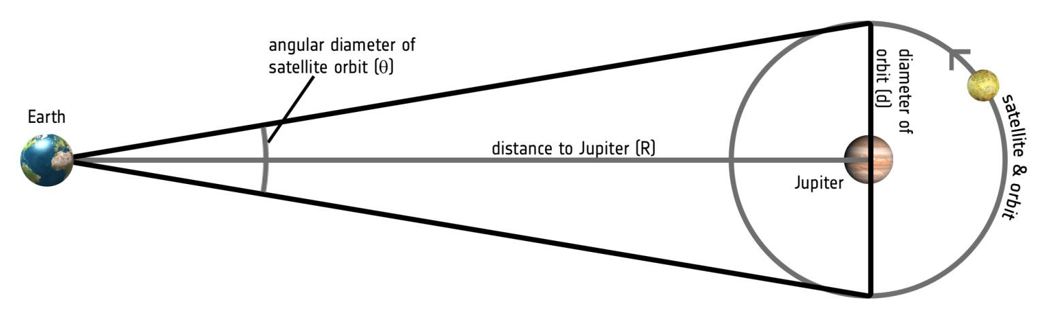

- Use the values you have calculated to work out the radius of the Moon’s orbit in km

- Using the values you have calculated, what is the mass of Jupiter?

- Does the value depend on which Moon you use?

