Finding Dark Matter
The velocity of an orbiting body and the mass of the object it is orbiting are linked by the following equation:
$$v^{2}=\frac{GM}{r}$$
Where v is the velocity of the orbiting object, r is the radius at which it is orbiting, M is the mass of the central object, and G is Newton's gravitational constant [6.67x10⁻¹¹ m³ s⁻² kg⁻¹].

We can use the formula above to predict the orbital velocity of a star around the centre of a galaxy, but we first need to know the galaxy's mass. Using observations of its luminosity, the mass of an example galaxy has been calculated to be approximately 28 billion solar masses.

Assuming that the entire mass of the galaxy is in the centre, use our Kepler's Law to predict the rotational velocity of the galaxy at the different radii in the table below, and plot a graph on graph paper.

Radius (lightyears) | Velocity (km s⁻¹ )
10000
20000
40000
60000
80000
100000

Is this a sensible model for a galaxy?
Observed Galaxy's Rotation curve :

This is the rotation curve that is actually observed for the galaxy. One parsec is 3.25 lightyears.
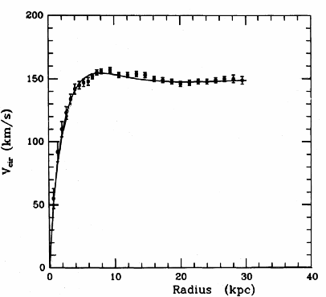

Does this curve look like the one you predicted? In what ways does it differ?

To help explain the difference between the predicted and observed rotation curves, use Kepler's Law again, but this time with velocity as your input to find the mass distribution at the radii listed in the table below.
How do these masses compare to our initial assumptions?

How does dark matter explain the difference?

Radius (lightyears) | Velocity (km s⁻¹ ) | Mass (M๏)
10000
20000
40000
60000
80000
100000

How do these masses compare to our initial assumptions?

How might dark matter explain the difference?

Estimate the ratio of Dark Matter to the normal matter we see in stars/gas?

